LOCAL PENSIONS PARTNERSHIP INVESTMENTS LIMITED
Lancashire County Pension Fund
Pension Fund Committee | 30 November 2018
Responsible Investment Report

Title of Paper | Quarterly Report on Responsible Investment (2018 Q3)
Lead Officer: | Frances Deakin  Responsible Investment Manager  Local Pensions Partnership Investments Ltd  frances.deakin@localpensionspartnership.org.uk
Appendices | Annex A1 – LPP I RI Policy - Annex on Climate Change  Annex A2 – Press Release

- Executive Summary

This report provides members of the Pension Fund Committee of Lancashire County Pension Fund (LCPF) with a quarterly update on Responsible Investment (RI) matters.

- Introduction

The Fund's approach to RI is articulated within an Investment Strategy Statement (ISS) which confirms that the objective of RI is to decrease investor risk, improve risk-adjusted returns and assist the Fund's adherence to the UK Stewardship Code. LCPF’s ISS is supplemented by a Responsible Investment Policy which explains that the Fund's preferred approach to RI encompasses four main areas of activity:
- Voting Globally
- Engagement through Partnerships
- Shareholder Litigation
- Active Investing

Responsibility for the practical implementation of the Fund's approach to RI is devolved to Local Pensions Partnership Investments Ltd (LPP I) as LCPF's provider of investment management services. The report which follows provides the Committee with an update on RI activity during the period 1 July to 30 September 2018 plus insights on current and emerging issues.

- Voting Globally

Through its investment in the LPP I Global Equities Fund (GEF) LCPF owns units in a pooled fund which invests in listed companies globally. Investors in the GEF delegate the control and exercise of shareholder voting to LPP I. This reflects that clients owning units in the GEF are beneficial owners in common but do not directly own shares in underlying companies.

LPP I exercise shareholder voting rights for the GEF centrally rather than delegating voting to individual asset managers and take account of voting recommendations from an external provider of proxy voting and governance research (ISS) in accordance a Sustainability Voting Policy designed to ensure the consideration of ESG factors within analysis. LPP I review voting recommendations and take the final decision on all voting.

In the third quarter of 2018 shareholder voting headlines for the GEF were as follows:

LPP I Global Equities Fund (GEF)

Total company meetings taking place | 69
Total resolutions  (management and shareholder proposals) | 674
Total company proposals in the period | 665
Total shareholder proposals in the period | 9

Company Proposals
Voting Supported Management | 608 | 91%
Voting Opposed Management | 57 | 9%

Shareholder Proposals
Shareholder proposals supported by LPP I | 7 | 78%
Votes against shareholder proposals | 2 | 22%

The following table summarises resolutions by type and indicates where opposition voting was concentrated in Q3.

 | Proposals
 | For | Against | Withhold | Total
Anti-takeover Related | 7 |  |  | 7
Capitalization | 75 |  |  | 75
Director Related | 279 | 34 | 3 | 316
Non-Salary Compensation | 55 | 7 |  | 62
Preferred/Bondholder | 4 | 6 |  | 10
Reorg. and Mergers | 13 | 4 |  | 17
Routine/Business | 175 | 3 |  | 178
SH-Compensation | 1 | 1 |  | 2
SH-Director Related | 1 | 1 |  | 2
SH-Health/Environment | 1 |  |  | 1
SH-Other/Miscellaneous | 2 |  |  | 2
SH-Routine/Business | 2 |  |  | 2
Total | 615 | 56 | 3 | 674

LPP I voted against management proposals in 56 instances.
This included opposing management nominations in the election / re-election of 31 directors. Voting reflected concerns with the composition and independence of company boards as a whole, and with the independence of individual Board members but also addressed instances of poor attendance at board and committee meetings in the prior year.

Management proposals on compensation arrangements prompted 7 opposition votes which mainly reflected the inadequate disclosure of information around performance conditions, vesting periods and the basis of some of the sub-components included within compensation calculations.

At the BT Group AGM, LPPI voted against the Remuneration Report as a reflection of misalignment between the bonuses due to be paid to the CEO and Financial Director and Corporate Performance (and the experience of shareholders via share price) in the same period.

LPP supported 7 shareholder proposals across 6 company meetings in Q3.
Most reflected what are now familiar (Governance) themes and gained a reasonable level of support whilst ultimately falling short of the majority required for adoption:
- improved shareholder rights
H&R Block Inc (US Consumer Services)– require shareholder approval for byelaw amendments agreed by the Board – 2% support, McKesson Corp (US Healthcare) - reduce the ownership threshold for Shareholders to call Special Meetings – 47% support.
- greater transparency
McKesson Corp – provide a report on political lobbying - 38% support,
Nike Inc (US Consumer Durables & Apparel) provide a report on political contribution policies - 27% support.

A shareholder resolution on a more individual (Social/Environmental) issue arose at the Darden Restaurants AGM where the request was for an assessment (by the USA’s largest restaurant chain) of the feasibility of phasing out the routine use of medically important antibiotics from its meat supply chain. The resolution received 40% support, which was a significant increase on similar resolutions at the last two AGMs which gained 9% and 13% support respectively. The two previous proposals asked for the adoption of a policy to eliminate the use of medically important antibiotics for disease prevention purposes, while this year's proposal asked for a report evaluating the feasibility of adopting such a policy.

Support for the resolution reflected that a growing number of Darden’s peers have committed to eliminating the use of medically important antibiotics in their animal agriculture supply chains, and Darden could be at risk of becoming a laggard.

Members can view details of voting for all meetings via the LPP website where quarterly reports for the GEF are made publicly available.

https://www.localpensionspartnership.org.uk/what-we-do/investment-management

- Engagement through Partnerships

LPP I regularly participates in collaborations which aim to make progress on commonly held issues by co-ordinating the efforts of multiple investors. Key partners include the Local Authority Pension Fund Forum (LAPFF) the Pensions and Lifetime Savings Association (PLSA) the Principles of Responsible Investment (PRI) the Institutional Investor Group on Climate Change (IIGCC) the LGPS Cross Pool RI Group, and the UK Pension Scheme RI Roundtable.

LAPFF

LAPFF has long been LCPF's preferred engagement partner.
The Forum’s most recent quarterly Business Meeting took place on 10 October 2018 and received a range of papers including:

Board-level employee representation
An update on new requirements around employee representation introduced under the recently revised UK Corporate Governance Code, which includes 3 options for company engagement with staff:
- a director appointed by the workforce;
- a formal workforce advisory panel;
- a designated non-executive director.
The new requirement applies on a comply or explain basis after 1 Jan 2019 for premium listings. LAPFF will be engaging with a sample group of companies around their planning and preferences in order to produce further guidance for Funds wishing to engage with companies on this theme going forward.

Industry associations and lobbying

LAPPF is to refresh current guidance around expectations of companies who are members of trade and other representative bodies. Changes will address the issue of a potential mis-alignment between what a company may state publicly and to their shareholders (e.g. about their commitments on climate change and sustainability) and what trade bodies acting in their name may be doing, such as lobbying against progressive policy change.
We have seen examples of shareholder resolutions seeking better disclosure on the lobbying activities of companies (mainly in the US) in Q3 2018 and prior periods which are addressing a similar issue in seeking to encourage good practices which reflect and supports the interests of shareholders.

LAPFF Q3 Engagement Report

The LAPFF engagement programme reflects the Forum's assessment of key priorities from across the collective equity holdings of LAPFF members. On a quarterly basis LAPFF provides a summary of the engagement activities undertaken on behalf of member funds which is available from the LAPFF website. http://www.lapfforum.org/publications/qrtly-engagement-reports/

Quantified across thematic topics, engagement activity by LAPFF in Q3 was as follows:
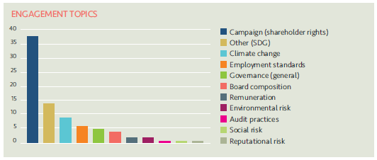

The 63 companies engaged with and the topics covered by LAPFF in Q3 were as follows:
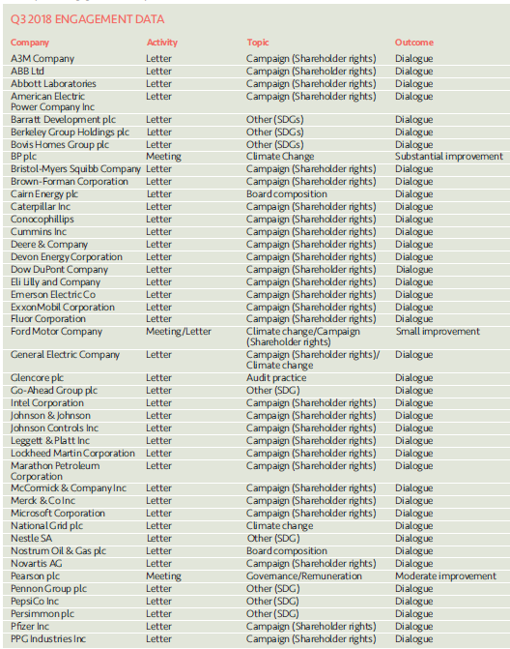
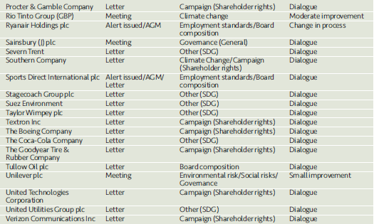

The campaign (shareholder rights) is focussed on the issue of contradictory lobbying which was touched upon above. Along with 80 investors, LAPFF have been named on letters to 45 US companies that serve on the National Association of Manufacturers’ (NAM) board. NAM has commissioned a report on shareholder engagement which conveys negative messaging about investor engagement and shareholder resolutions in general and about climate change in particular. The joint letter expresses particular concerns at the report funded and distributed by NAM, which asserts that shareholder resolutions diminish company value. The letters call for companies to distance themselves from NAM’s position and to communicate their concerns to NAM leadership, arguing that NAM’s stance is in direct contradiction to the dialogue companies are having in private with their investors and messaging within their public reporting to shareholders and stakeholders.
Principles of Responsible Investment (PRI)
LPP became a signatory to the PRI in place of LCPF and LPFA over the summer which has removed prior barriers to accessing policy and guidance materials and to considering participation in collaborations under the co-ordination of the PRI.
LPP I recently met with PRI staff directly to begin a dialogue, explore resources available and be introduced to opportunities for consideration within future planning (subject to there being a good fit with our engagement priorities).
Shareholder Litigation
LPP I employ Institutional Protection Services (IPS) as an external provider of litigation monitoring services to ensure shareholder litigation cases affecting securities owned by the GEF are known about, claims are filed in a timely way and progress is monitored and followed up with Claims Administrators. In addition, IPS monitor cases relating to shares held by LCPF in the period before the Fund pooled its listed equity investments from November 2016. Litigation can arise quite some time after shares have been sold and monitoring new cases and referring back to historic holdings records to establish rights of ownership is an ongoing task.
IPS provide LPP I with monitoring information on a quarterly basis detailing the number of cases investigated. The monitoring report for Q3 2018 confirms that of 10 potential cases identified where the Fund might have an entitlement to join a class action, further analysis had discounted 2. There are 3 cases where eligibility is still being assessed and 5 where eligibility has been confirmed and a claim will be filed.

- Active Investing

The LCPF Responsible Investment Policy describes active investing as the search for sustainable investments which meet LCPF’s requirements for strong returns combined with best practice in ESG and corporate governance. The Fund has not set allocations for investments within specific sectors but favours sustainable investments with positive social characteristics.
The following examples share information on developments which will contribute to ensuring the sustainability of the portfolio over the long term.
LPP I Policy on Climate Change

As a supplement to the LPP I Responsible Investment Policy, LPP I has published an Annex on Climate Change which describes the approach to understanding and managing the risks and opportunities climate change presents for the portfolios we manage on behalf of client pension funds.
A copy of the new Annex on Climate Change is attached at Annex A1 and describes steps LPP I is already taking and broader areas identified for further development going forward.
Details include
- a commitment to cease investing in thermal coal extraction through our Global Equities Fund by divesting existing holdings and placing an exclusion on further investments in this sector. We are working through the challenges associated with expanding the exclusion to include other asset classes.
- qualitative targets around our investment in companies involved in fossil fuel extraction. These reference the Transition Pathway Initiative (TPI) Management Quality stairway which assigns companies to one of 5 levels based on their recognition and management of transition risks.
Our target is that fossil fuel companies we invest in should be rated at a minimum of TPI level 2 (Building Capacity) in 2018 and TPI Level 3 (Integrating into Operational Decisions-Making) in 2019.
Climate Science and Asset Management

One of our external managers with mandates in both the LPPI Global Equities Fund and Global Fixed Income Fund (Wellington) has confirmed an exciting new collaboration with Woods Hole Research Center (WHRC), the world’s leading independent climate research institute. The aim of the initiative is to advance collective understanding of the investment risks faced from climate change by bringing a deeper, fact-based understanding to the integration of climate science and asset management. The intended outcome is the creation of quantitative models which analyse how and where climate change may impact global capital markets.
As a result of the initiative, Wellington and WHRC will collaborate on a broad range of projects, including developing investor tools and innovative analytical methods to enhance climate risk assessment. A press release providing further details on the collaboration is attached at Annex A2.
LPP I will receive ongoing updates from Wellington on the progress of their collaboration as part of ensuring insights are shared and any tools developed can be considered for integration going forward.

